**Name:** Vineel Sai

**Reg No:** 498

**AIM:** To make a CAR

**Introduction:** Making a car with Arduino which can drive front/back and left/right in simulator mode in Arduino UNO Simulator, it can also make sound with beeper and has a led as head light.

**Working Principal:** It works by using push buttons as input devices and corresponding components as output devices. The components used are 1x SERVO, 1x MOTOR, 4x Push buttons, 1x LED, 1x BUZZER.

**Circuit Diagram:**

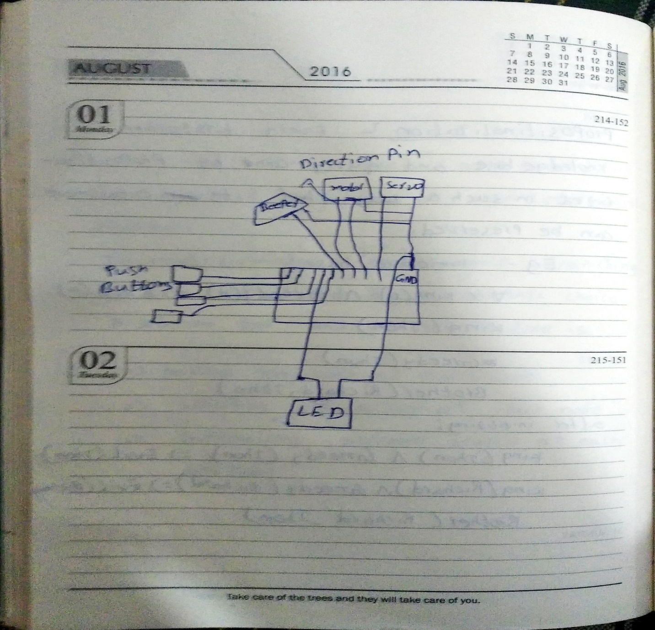

**Photograph of Implemented circuit:**

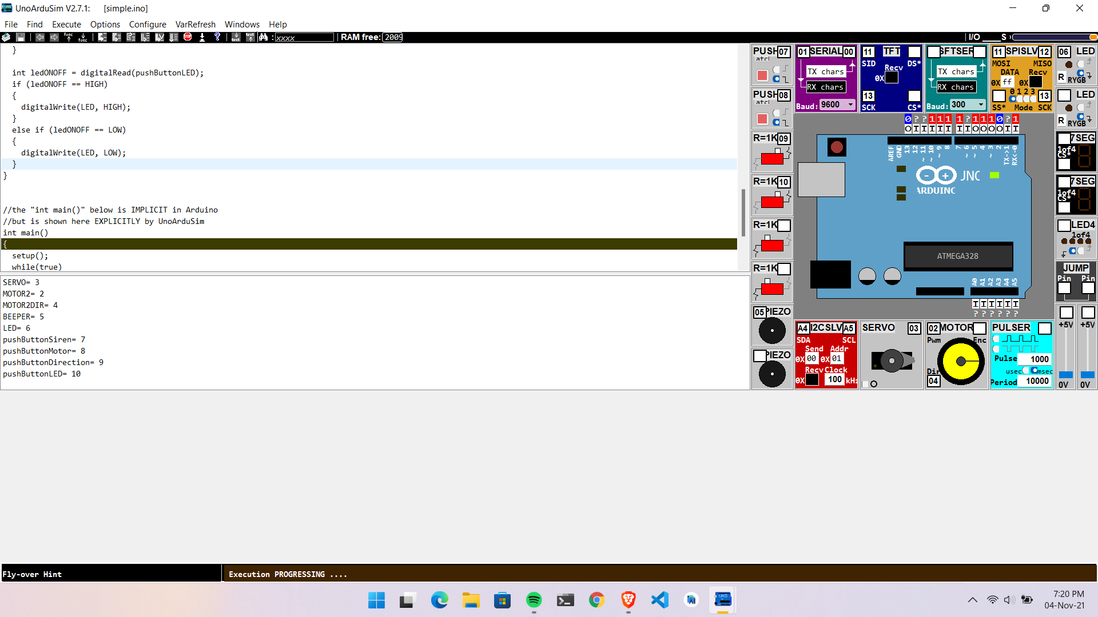

**Results:** The car always move forward you can control the direction by pressing push button 1 to right push button 1&2 combined to left, turn siren on by pressing push button 3 and turn LED on by pressing push button 4.

Conclusion: With real world components we can make a car witch can function as a toy and can extend it with remote control capability to make it more useful and can use it to get help in reaching places where humans cant easily reach.

**CODE:**

int SERVO=3;

int MOTOR2=2;

int MOTOR2DIR=4;

int BEEPER=5;

int LED=6;

int pushButtonSiren=7;

int pushButtonMotor=8;

int pushButtonDirection=9;

int pushButtonLED=10;

void setup()

{

pinMode(SERVO, OUTPUT);

pinMode(MOTOR2, OUTPUT);

pinMode(MOTOR2DIR, OUTPUT);

pinMode(BEEPER, OUTPUT);

pinMode(pushButtonSiren, INPUT);

pinMode(pushButtonMotor, INPUT);

pinMode(pushButtonDirection, INPUT);

pinMode(pushButtonLED, INPUT);

}

void loop()

{

digitalWrite(SERVO, HIGH);

int siren = digitalRead(pushButtonSiren);

if (siren == HIGH)

{

digitalWrite(BEEPER, HIGH);

}

else if (siren == LOW)

{

digitalWrite(BEEPER, LOW);

}

int motorStart = digitalRead(pushButtonMotor);

if (motorStart == HIGH)

{

digitalWrite(SERVO, HIGH);

}

else if (motorStart == LOW)

{

digitalWrite(SERVO, LOW);

}

int motorDirection = digitalRead(pushButtonDirection);

if (motorStart == HIGH)

{

digitalWrite(MOTOR2DIR, HIGH);

}

else if (motorStart == LOW)

{

digitalWrite(MOTOR2DIR, LOW);

}

int ledONOFF = digitalRead(pushButtonLED);

if (ledONOFF == HIGH)

{

digitalWrite(LED, HIGH);

}

else if (ledONOFF == LOW)

{

digitalWrite(LED, LOW);

}

}